Docker
Docker is a software container platform that makes it easy to develop deploy inside, and delopy taps inside a nicely package environment.
The idea behind the process of setting up and running a container for an application is to create a text document that contains all commands. The user could call on the command line to build an image and once the image is built docker run. Docker file: a text document that contains all the commands a user could call to build and image.
Users need to build first image using the docker build commands
Docker file # build docker image # run docker container
Container Image: The file system and parameters needed to run application. It does not have any state and does not change. If you’re new to container images, think of them as a standardized package that contains everything needed to run an application, including its files, configuration, and dependencies. These packages can then be distributed and shared with others.
Container: a running instance of an image. It has a state and can change.
#docker build -t hello-internet .
Pointing at the end is so important. It means that save this local path.
A Docker file is text file that contains the explanations used to build a Docker image. Docker files mostly include:
- FROM: This includes base image structure base image start from the Docker Hub. (e.g., ubuntu: latest, python:3.9, parflow: latest, modflow: latest).
- WORKDIR: working directory inside the container. (app)
- COPY: Copies files or directories from your GitHub into the image.
- ENV: Sets environment variables.
- CMD: Provides default commands for an executing container.
How to map Ports in Docker?
In docker, all the applications in the container runs ports when you run a container. If you want to access the particular application with help of a port number, you need to map the port number of the container with the port number of docker host.
What are Ports in Docker?
The ports in docker are essential for enabling communication between docker containers and outside of the world via the internet. It helps in defining the endpoints through which services can be hosted within the containers and can be accessed by external entities. Docker uses port mapping to map the ports that expose within a container to ports on the host system. It allows the services that are running within the containers to be accessed externally visa host’s IP address and port number combination.
Why we Use Port Mapping?
The networks services of containers are made accessible to the host or external network through port mapping in Docker. Docker containers can only communicate with other containers on the Same Docker network and run by default in isolation from the host and external networks. By publishing a container’s network service to the host or external network through port mapping, you can make it reachable from other networked devices.
When running a Docker container, you can map a port on the container to a port on the host or external network using the -p or publish options
If you use the below command, it will publish nginx, for instance, would publish port 80 from container to port 8080 on the host or external network.
docker run -p 8080:8080 docker name(nginx)
to publish the container’s port 80 to host port 8080:
docker run -d -p 8080:80 nginx
Now, any traffic sent to port 8080 on you host machine will be forwarded to port 80 with in the container.
Publishing ports
Publishing a port provides the ability to break through a little bit of networking isolation by setting up a forwarding rule. As an example, you can indicate that requests on you host’s port 8080 should be forwarded to the containers’ port 80. Publishing ports happens during container creation using the -p or –publish
Important:
When a port is published, it is published to all network interfaces by default. This means any traffic that reaches your machine can access the published application. Be mindful of publishing databases or any sensitive information.
Why are image digests important?
Using image digests instead of tags offers several advantages:
Immutability: Once an image is built and its digest is generated, the content tried to that digest can not change. This means that if you pull an image using its digest, you can be confident that you are retrieving the same image that was originally built.
Security: Digests help prevent supply chain attacks by ensuring that the image content has not been tampered with. Even a small change in the image content will result in completely different digest.
Consistency: Using digests ensures that the same image is used across different environments, reducing the risk of discrepancies between development, staging and production environments.
To create docker image we need to
Docker build . (With this code we have built Image id +digest number)
Example
Docker build -t-hello internet .
We build images but we do not have a container yet
“Docker run – d -p 80:80 image id “
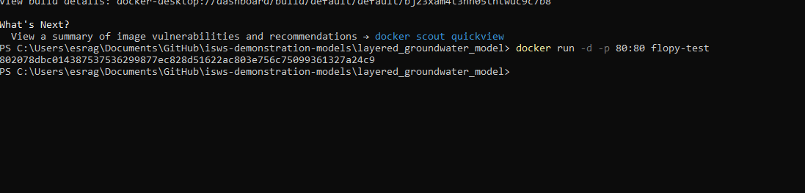
-d = detachment (I did not understand this part. Sorry) sometimes we do not include that part.
-p = port number
Docker ps running
Note:
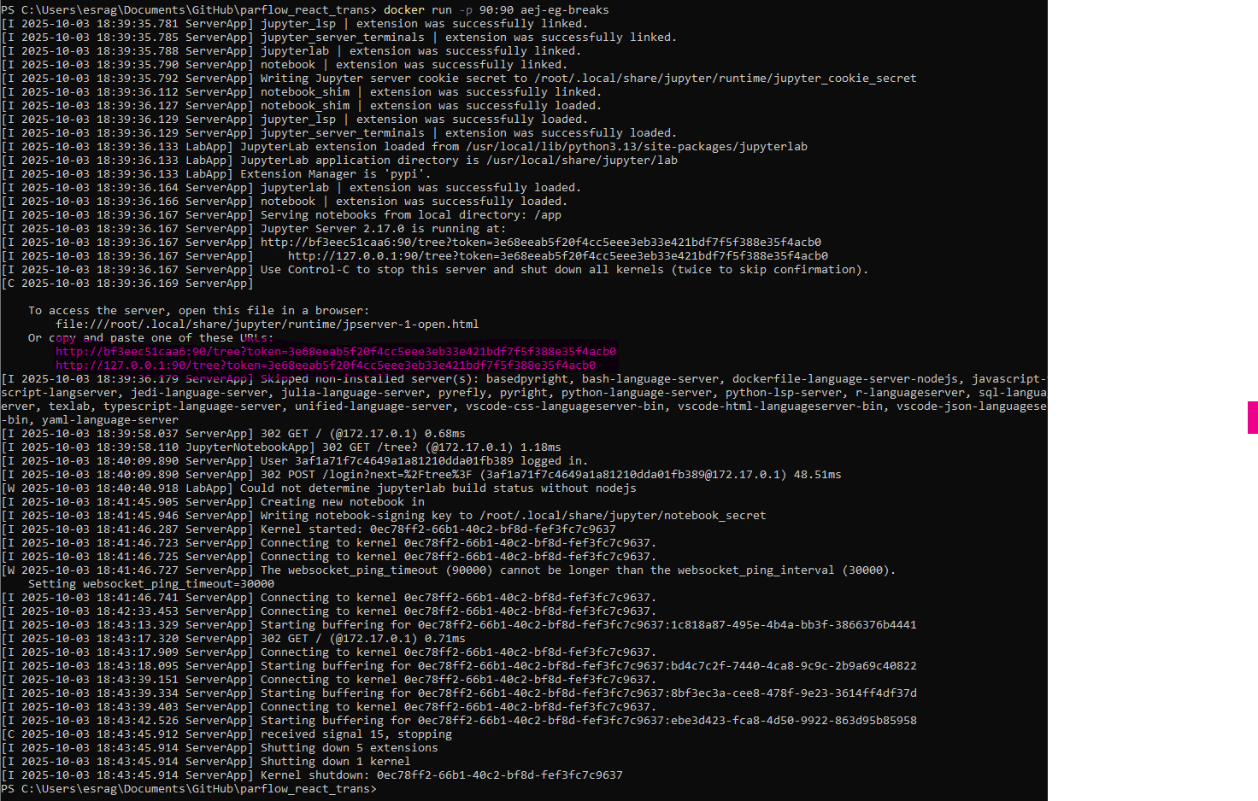
How can we save the docker hub and can anyone pull this work?
The default docker images will show all top level images, their repository and tags, and their size.

Create an image repository
Now that you have an account, you can create an image repository. Just as a Git repository holds source code, an image repository stores container images.
- Go to Docker Hub.
- Select Create repository.
- On the Create repository page, enter the following information:
  - Repository name -
  - Short description - feel free to enter a description if you'd like
  - Visibility- select Public to allow others to pull your customized to-do app
- Select Create to create the repository.
docker login
Username:
Password: Token
To create a personal access token:
- Sign in to Docker Home.
- Select your avatar in the top-right corner and from the drop-down menu select Account settings.
- Select Personal access tokens.
- Select Generate new token.
- Configure your token:
  - Description: Use a descriptive name that indicates the token's purpose
  - Expiration date: Set an expiration date based on your security policies
  - Access permissions: Read, Write, or Delete.
- Select Generate. Copy the token that appears on the screen and save it. You won't be able to retrieve the token once you exit the screen.
Use personal access tokens
docker login --username YOUR_USERNAME
Password: [paste your PAT here]
When prompted for a password, enter your personal access token instead of your Docker Hub password.
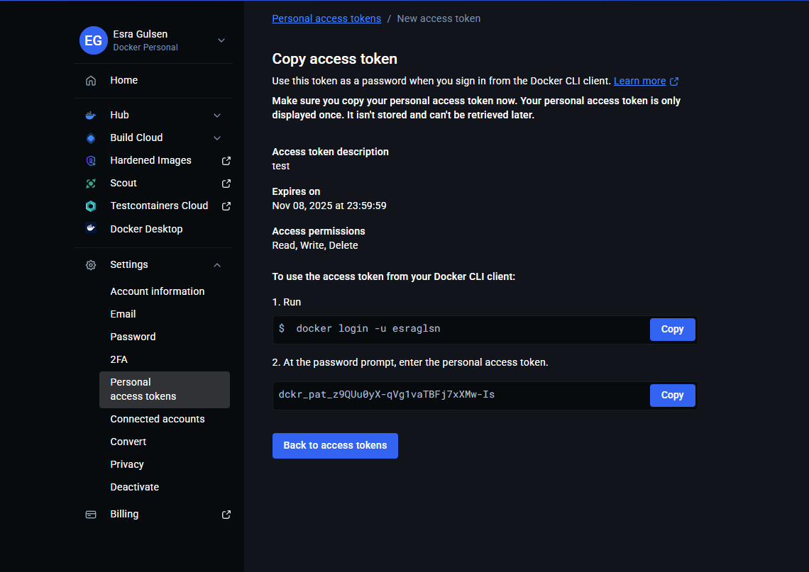

docker tag flopy-test:latest esraglsn/testing-repo-save.
(docker tag(command))
Image name: (code) image version (tag)
repository name
docker push esraglsn/testing-repo-save:flopy-test>
docker push repository name: first image
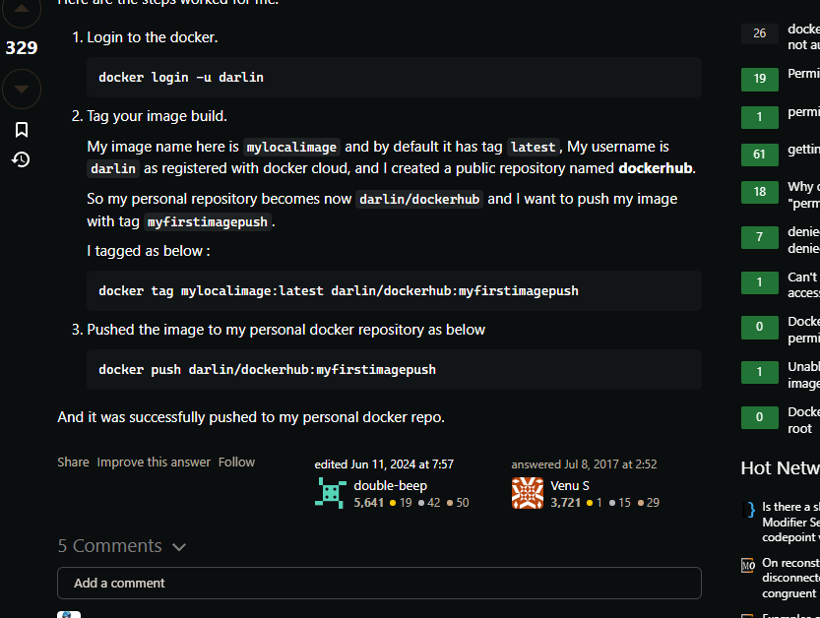

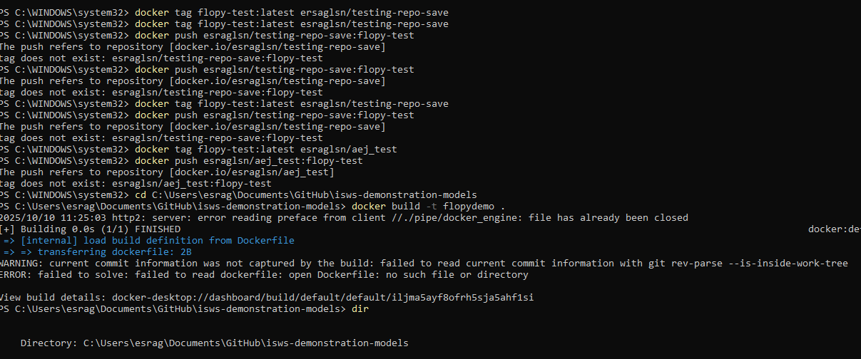
Summary of all (Example):
docker build -t flopydemo .
docker run -dp 85:85 flopydemo
docker tag flopydemo:latest esraglsn/aej_test
docker push esraglsn/aej_test:flopydemo
docker push esraglsn/aej_test:latest

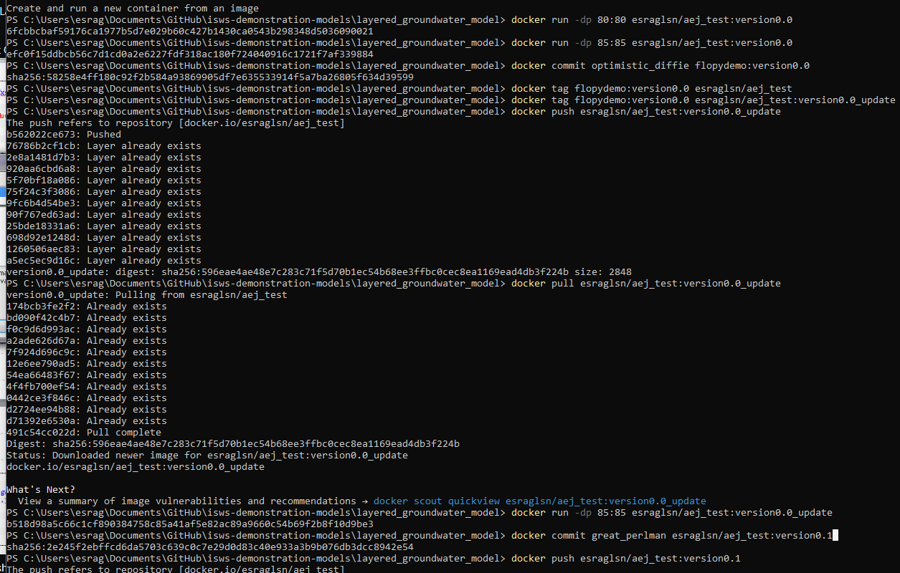
Notes for Esra:
https://medium.com/@18bhavyasharma/setting-up-and-running-jupyter-notebook-in-a-docker-container-d2acd713ce66
We watched this video many times (It might be great start to remember)
https://www.youtube.com/watch?v=SnSH8Ht3MIc
(Techno Tim)
https://www.youtube.com/watch?v=Gd9bvdkIXOQ
To understand Jupyter notebook installation:
https://medium.com/@18bhavyasharma/setting-up-and-running-jupyter-notebook-in-a-docker-container-d2acd713ce66
Push and save your image
https://stackoverflow.com/questions/41984399/docker-push-error-denied-requested-access-to-the-resource-is-denied
https://docs.docker.com/security/access-tokens/

